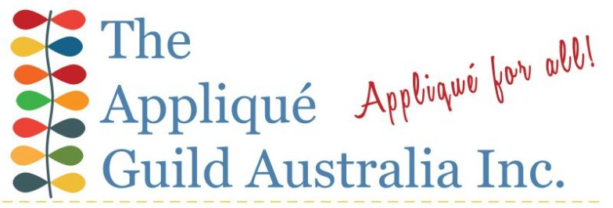
Technique Workshop Application
Please complete and return the application and payment to The Secretary of The Applique Guild of Australia Inc.
Surname: |  | Given Name:
Address:
Phone: |  | Mobile:
Email:
Available Worksop’s
Wendy Blyth | Sue Cheney | Michelle Yeo | Maureen Mackie
Needleturn Applique | Machine Applique | Broderie Perse | Back Basting
Please number workshop in order of preference. You can participate in 2 half day workshops.
Workshop Cost
Member: | $80 | Non-Member: | $100
Accommodation  Includes B&B | 1 night $99 | 2 nights $198
Lunch  Soup and sandwiches | $20
Dietary Requirements
Total Payable | $ …………………………………………..
Payment Method
Direct Deposit
Bank: Bendigo Bank BSB: 633 000 Acct No:146672456
Account name: The Applique Guild of Australia Inc.
Reference: Insert your full name

Payment by Credit card or PayPal
Login to your PayPal account, select your method of payment Credit card or PayPal. Click the SUBMIT button when completed.
Payment by Cheque
Cheque payable to: The Application Guild of Australia Inc.
Postal Address: P.O. Box 217 Bulleen 3105 Victoria Australia
Please remember your cheque must be cleared before your registration can be confirmed.

